Assignment 3

JAvA spring boot

Name: Vinay Raj Likith (20BCE2613)

**CODE:**

**package** fat; **import** java.sql.Connection; **import** java.sql.DriverManager; **import** java.sql.PreparedStatement; **import** java.sql.ResultSet; **import** java.sql.SQLException; **import** java.util.Scanner;

# public class thd {

**public** **static** **void** main(String[] args) { **int** login, user_login, event = 0; Scanner sc = **new** Scanner(System.***in***); **try** {

Class.*forName*("com.mysql.cj.jdbc.Driver");

Connection conn =

DriverManager.*getConnection*("jdbc:mysql://localhost:3306/s tu", "root", "somu@123");

System.***out***.println("Enter 1 for user login"); System.***out***.println("Enter 2 for admin login"); login = sc.nextInt(); **if** (login == 1) {

System.***out***.println("Enter 1 for new record entry");

System.***out***.println("Enter 2 for user updation");

event = sc.nextInt(); **if** (event == 1) {

System.***out***.println("Enter user id");

String a = sc.next(); System.***out***.println("Enter user name");

String b = sc.next();

System.***out***.println("Enter user age"); **int** c = sc.nextInt();

System.***out***.println("Enter user phone number");

**long** d = sc.nextLong();

String sql = "INSERT INTO students

(id, name, age, phonenumber) VALUES (?, ?, ?, ?)"; PreparedStatement statement = conn.prepareStatement(sql);

statement.setString(1, a); statement.setString(2, b); statement.setInt(3, c); statement.setLong(4, d);

**int** rowsInserted = statement.executeUpdate();

**if** (rowsInserted > 0) {

System.***out***.println("A new record has been inserted successfully.");

}

statement.close();

# } else {

System.***out***.println("Enter the user id to update");

String id = sc.next();

System.***out***.println("Enter new user name");

String name = sc.next();

System.***out***.println("Enter new user age");

**int** age = sc.nextInt();

System.***out***.println("Enter new user phone number");

**long** phoneNumber = sc.nextLong();

String sql = "UPDATE students SET name=?, age=?, phonenumber=? WHERE id=?"; PreparedStatement statement = conn.prepareStatement(sql);

statement.setString(1, name); statement.setInt(2, age); statement.setLong(3, phoneNumber); statement.setString(4, id);

**int** rowsUpdated = statement.executeUpdate();

**if** (rowsUpdated > 0) {

System.***out***.println("User details have been updated successfully.");

# } else {

System.***out***.println("No user found with the provided ID.");

}

}

} **else** **if** (login == 2) {

// Operations for admin login

System.***out***.println("Enter 1 to show the all records");

System.***out***.println("Enter 2 to drop records");

**int** f=sc.nextInt(); **if**(f==1) {

String sql = ("SELECT *FROM students"); PreparedStatement statement = conn.prepareStatement(sql);

ResultSet resultSet =

statement.executeQuery();

**while** (resultSet.next()) {

String id = resultSet.getString("id");

String name = resultSet.getString("name");

**int** age = resultSet.getInt("age"); **long** phoneNumber = resultSet.getLong("phonenumber");

System.***out***.println("ID: " + id + ", Name: " + name + ", Age: " + age + ", Phone Number: " + phoneNumber); } } **else** {

String sql = "DROP TABLE students"; PreparedStatement statement = conn.prepareStatement(sql);

statement.executeUpdate();

System.***out***.println("The table

'students' has been dropped.");

}

# } else {

System.***out***.println(" Invalid login option");

}

conn.close();

} **catch** (ClassNotFoundException e) { System.***out***.println("Error occurred while loading the driver: " + e.getMessage());

} **catch** (SQLException e) {

System.***out***.println("Error occurred while connecting to the database: " + e.getMessage());

}

}

}

**Designed Architecture**:

Accessing

users

project

Sample

project

user

Record entry

updation

based on user

id

admin

view inserted

records

Droping the

table

**Output samples:**

**1 a)user record entry:** **Java console**

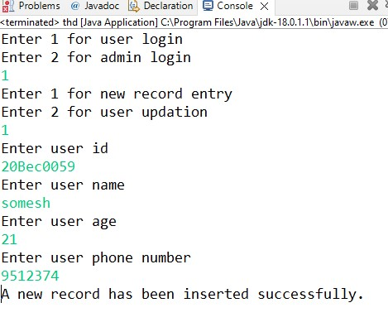

**Sql console:**

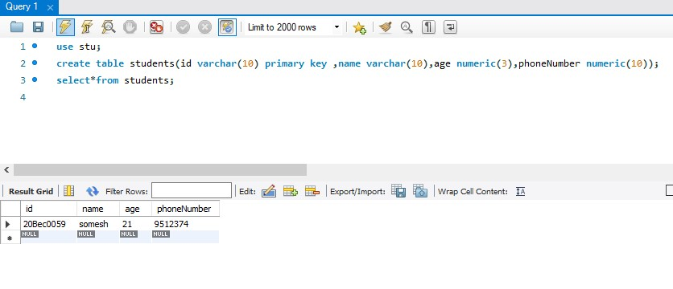

**1 b) user updation: Eclipse console**

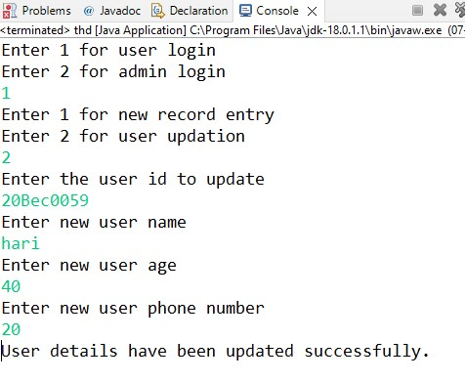

**Sql workbench console:**

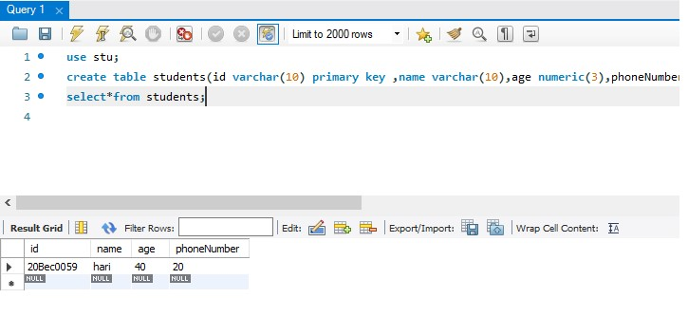

**2a)admin viewing inserted records:**

**For 1 record:**

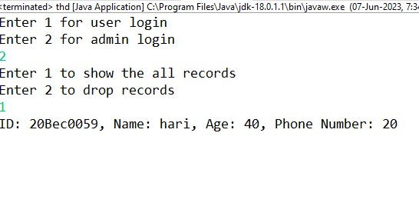

**For so many records:**

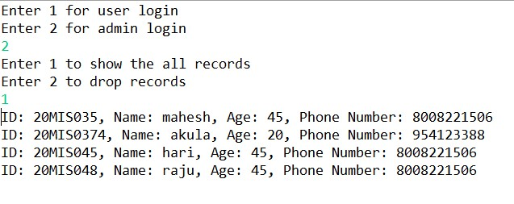

**2b)Droping table:**

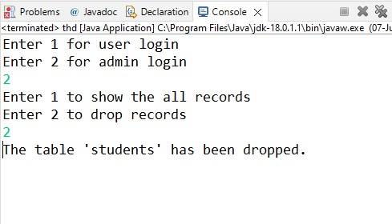

**\*\*\*\*\*\*Thank you\*\*\*\*\*\***